EXP.NO: 04 | AWK Scripting

AIM:

To study and implement AWK scripting for processing text files, performing mathematical calculations, and generating formatted outputs based on specific conditions.

ALGORITHM:

Initialization: Prepare an input data file named data.txt containing structured text with
multiple fields (e.g., ID, Name, Salary, and Scores).
- Input Reading: Read the input file line by line using the AWK utility.
- Field Extraction: Use positional parameters ($1, $2, $3, etc.) to access specific data
columns and built-in variables like NR for row numbers and NF for the count of fields.
- Summation Logic:
○ Initialize a accumulator variable (e.g., total = 0) in the BEGIN block.
○ Add the value of the target field (Salary) to the accumulator for every record processed.
○ Display the final sum in the END block after all lines are read.
- Conditional Filtering: Apply if statements to check specific criteria, such as identifying
employees with a salary greater than a defined threshold (e.g., 6000).
- Complex Logic Implementation:
○ Evaluate multiple fields simultaneously using logical operators (e.g., || for OR).
○ Check if any subject score is below the passing mark (e.g., 45).
○ Assign and print a status of "Pass" or "Fail" based on the result of the logical evaluation.
- Output Generation: Format and print the processed results to the standard output
(terminal).

CODE:

101 Ravi 5000 5 60 55 70
102 Sita 7000 6 40 50 65
103 Arun 6500 3 80 85 90
104 Meena 8000 7 30 60 75
105 Kiran 5500 4 72 68 74

awk '
BEGIN {total = 0}
{
total = total + $3
}
END {
print "Total Salary =", total
}' data.txt

awk '{
if ($3 > 6000)
print $2, $3
}' data.txt

awk '{
if ($5 < 45 || $6 < 45 || $7 < 45)
print $2, "Fail"
else
print $2, "Pass"
}' data.txt

OUTPUT:
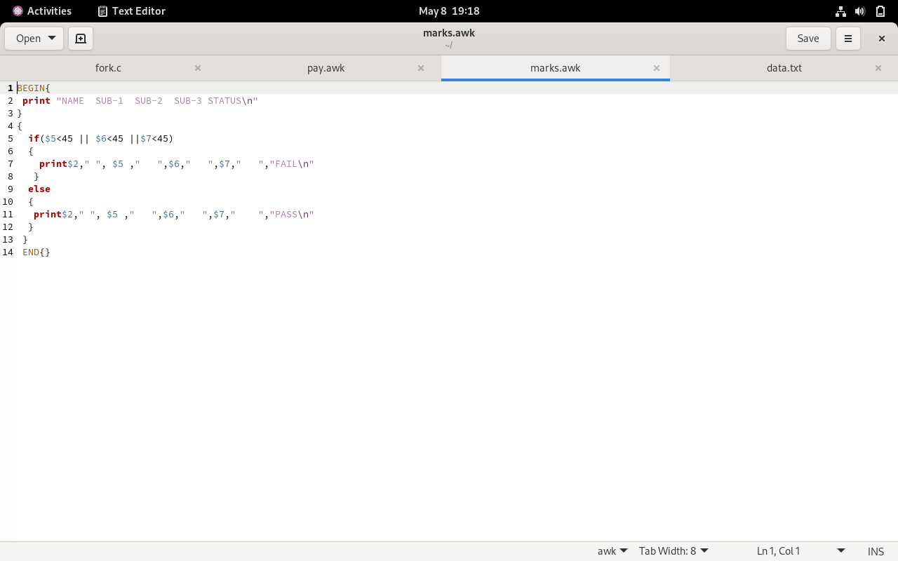

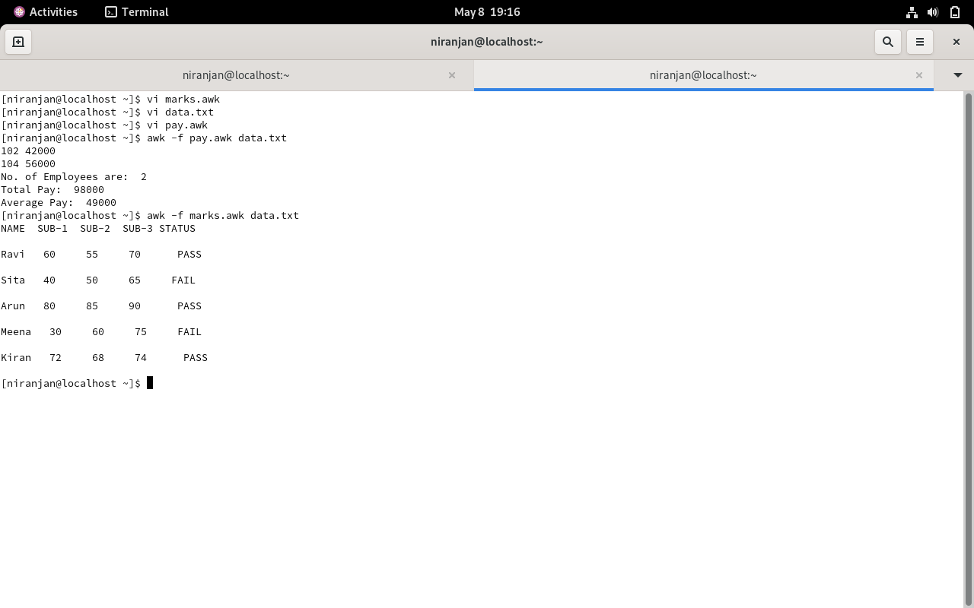

RESULT:
Thus, AWK scripting was successfully implemented to process text data, perform arithmetic calculations, and apply logical conditions to generate meaningful and formatted output.

